How to apply an IEEE IAS Student Branch Chapter
Before applying an IEEE IAS Student Branch Chapter, there must be at least 6 students who are both IEEE and IAS members or student members.
The Process of applying an IEEE IAS Student Branch Chapter is as follows：1. The temporary student chair fill in the petition form online——2. All IAS (student) members confirm this petition online——3. Chapter advisor confirms this petition online——4. Chapter Counselor confirms this petition online ——5. Waiting for IEEE and IAS confirmation.
IEEE Industry Applications Society Student Branch Chapter Petition form：
1. Log in the following website：http://ias.ieee.org/chapters-membership/chapter-information.html >>Petition >>> Online Petition Form >>> Access Petition Form.
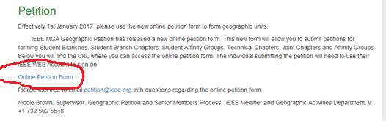
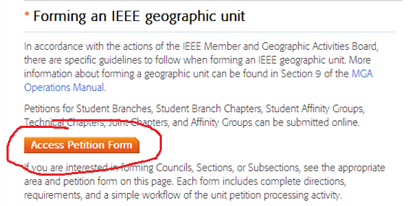
2. Log in your IEEE account：
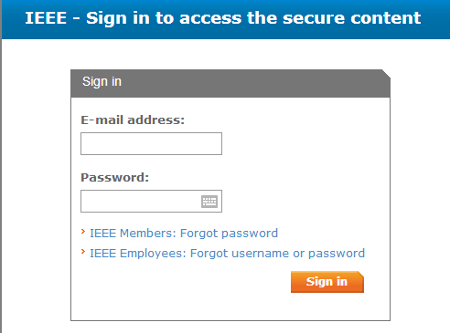
3.When create petition, please choose Student Branch Chapter.
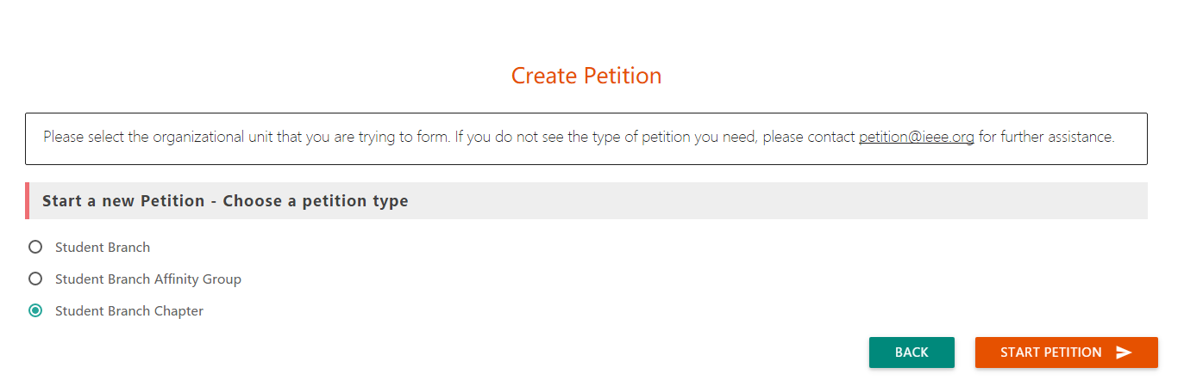
Fill in the information of petition form including information about student Chair, student members, chapter Advisor and Counselor. You need know the IEEE member number of the chapter Advisor and Counselor when you are filling in the form. After the information submitted, all student members will receive a confirmation request email. They can complete the online confirmation through the above 1 and 2 processes.

4 After all student members confirm this petition, the chapter Advisor and Counselor will receive an endorsement request email. They can complete the online confirmation through the above 1 and 2 processes. The endorsement page is as follows for an example:
In this figure, the chapter advisor has endorsed the petition and the student branch counselor has not.
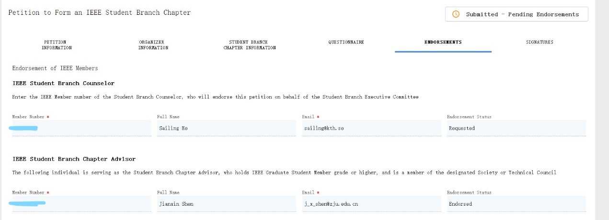

5. Waiting for IEEE and IAS confirmation.
Prepared by:
Ms. You Lin, IAS SB Chapters Area Chair, R-10 East Asia, email: youlin@zju.edu.cn

